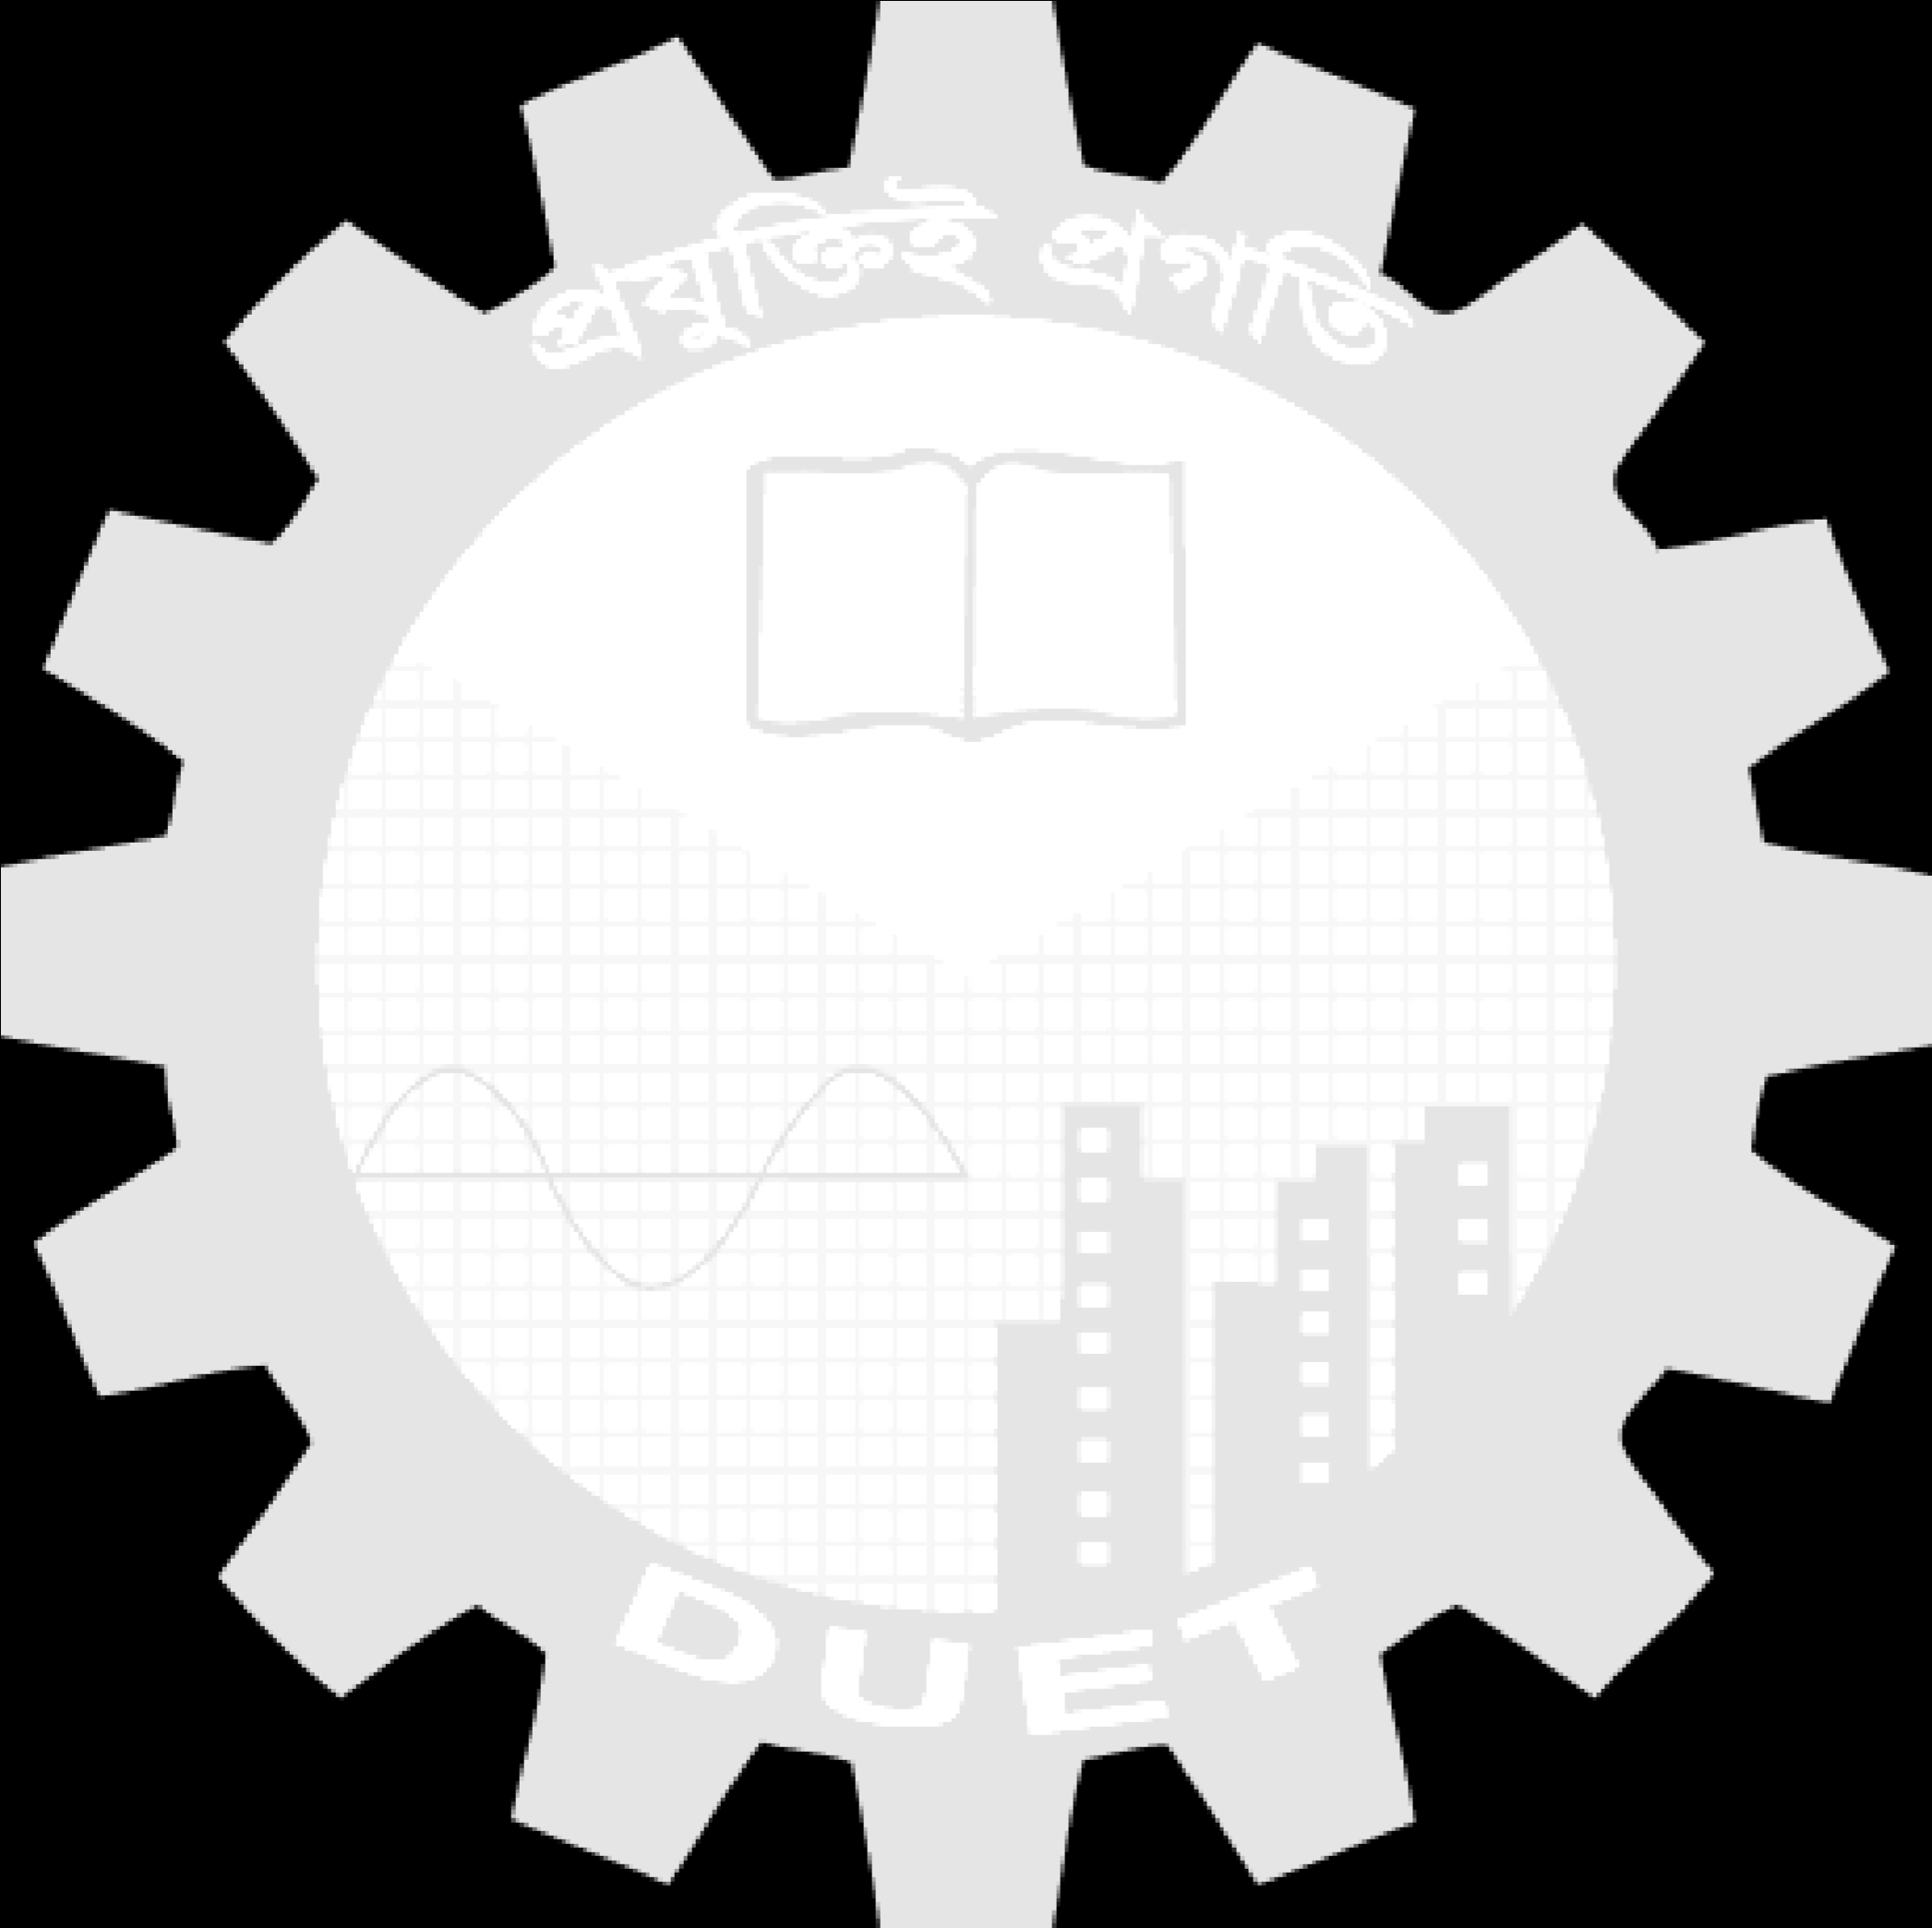

**Dhaka University of Engineering & Technology, Gazipur**

Department of Computer Science and Engineering

*Course Code: CSE 3812*

*Course Title: Microprocessor and Interfacing Sessional*

**Submitted To**

**Dr. Md. Jakirul Islam**Associate Professor

Dept. of CSE

DUET, Gazipur.

**Sumaya Khatun**Lecturer

Dept. of CSE

DUET, Gazipur.

____________________

Signature of Teacher

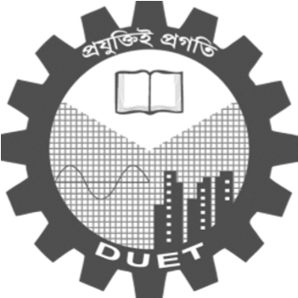

**Submitted By**

Group No :

Student ID :

Year/Semester : 3rd Year/ 1st Semester

Section : B



Date of Submission: / /

Date of Allocation: / /

**Report No :**

**Report Name :**